Client website Access on server

On client machine

# systemctl stop firewall

# setenforce 0

# yum install httpd

# cd /var/www/html

# vim index.html

!!!! Welcome to cdac !!!!!

:wq

Save and exit

# systemctl start httpd

# ip a

Copy this client ip and paste it on Web URL i.e 192.168.45.130

Go to the Pfsense web Ui then click on firewall —> NAT —> Port forwarding then click on add rule

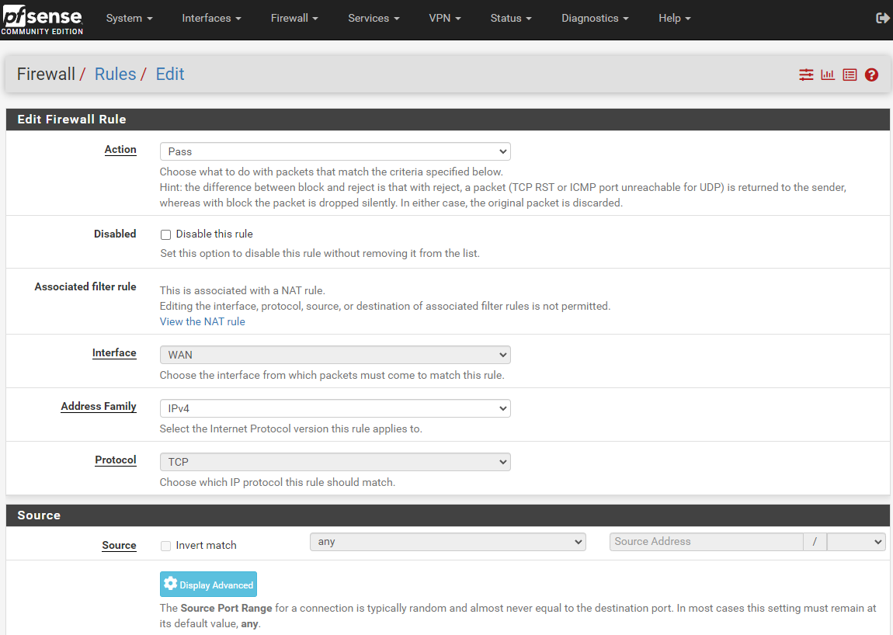

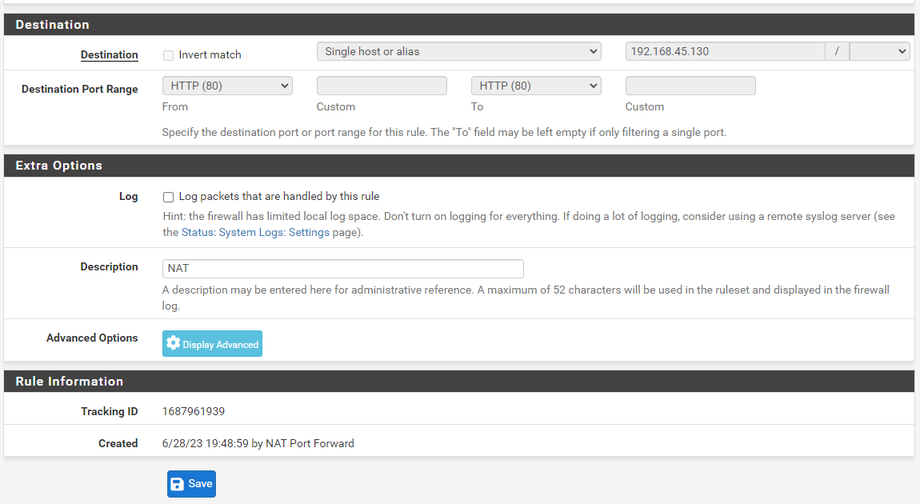

Go to the first rule SETTING

Scroll down

untick Reserved Networks first block Private networks and loopback address

Then click on save

